‘Isle Learn’: A Centre of Excellence for Health and Social Care Development on the Isle of Wight – Case Study: Part 1

Background

The concept of a ‘Centre of Excellence’ was first explored back in 2013 with a small group of development leads from across the health and social care system when the MLAFL programme was in its infancy.

During the initial planning for Vanguard status, during the early part of 2015, the concept was raised again and incorporated into the values proposition. When Vanguard status was awarded to the My Life a Full Life programme in the summer of 2015, a Workforce Development Lead was recruited in the late autumn and planning began to scope the ‘Centre of Excellence’.

Scoping

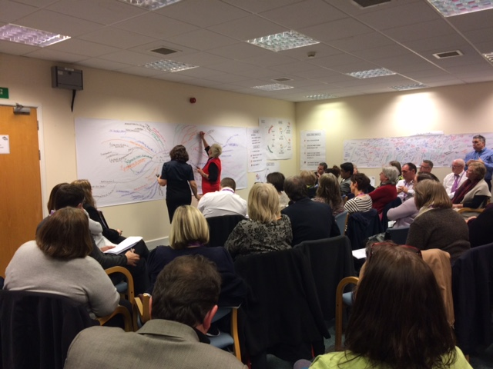
Workshops were held in March 2016 with over 50 stakeholders from across the Island’s health and social care system (representative of statutory, voluntary, private and independent organisations), as well as regional and national representatives including Health Education Wessex and the New Care Models team. The sessions were also attended by education providers from both on and off the Island.

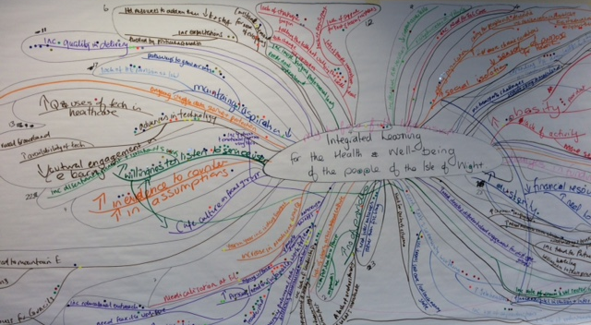
The scoping sessions were facilitated by Tricordant⁽¹⁾ using a ‘Future Search’ methodology, which was very task-focussed and enabled conversations related to past, present and desired future to aid development of action plans. In addition to the outputs for the Centre of Excellence, these sessions enabled invaluable networking and relationship building for those involved during the 3 days, with one attendee commenting that it was the best piece of co-production they had witnessed.

At the end of the second day, the group developed a ‘mind map’ which explored current issues that could impact on the development of a ‘Centre of Excellence’.
The mind map enabled the group to work on clarifying which key areas should be the focus of developing our implementation plans.

- www.tricordant.com
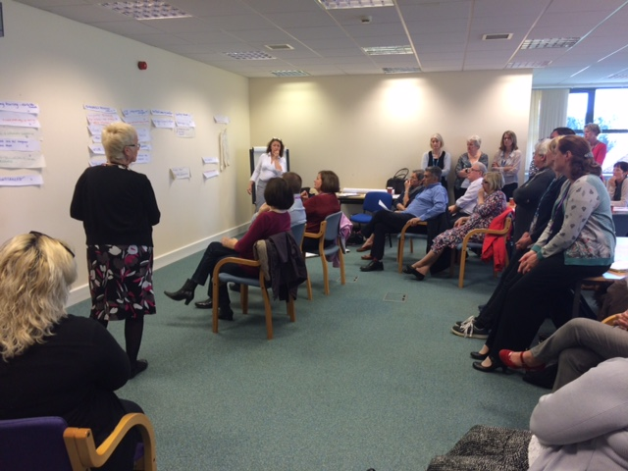

The outputs from the first two workshops were further developed during a planning day which was held in April 2016 and resulted in the development of ‘game plans’ for each of the key areas identified which include finance, IT, development of the existing and future workforce, development of the community, leadership, organisational development, research and development. These are all areas that were felt to be essential to the successful implementation of a ‘Centre of Excellence’.

Successes

The key successes from this initial scoping and planning work is that we have facilitated a large scale collaboration to develop first draft action plans in order to realise the vision of a truly integrated health and social care development centre for the workforce and people of the Isle of Wight.

In addition, networks have been built and feedback already provided to the Workforce Development Lead that some long standing queries and potential for collaboration have been further discussed and potentially resolved as a result of people meeting at the workshops.

A Senior Programme Manager for Health Education England, who is currently working with the New Care Models team to support Vanguard setting up integrated learning environments, attended the planning session, saying “The Isle of Wight is ahead of the game… It was good to see so many different organisations sitting around the table and collaborating across organisational boundaries.”

What next

Task and finish groups are currently being set up to explore existing and future provision, processes and systems, with a view to commencing work in July so that robust implementation plans can be developed and approved by the end of this financial year with our vision of ‘Isle Learn’ officially taking form in 2017.

Key Contact: Jacqui Skeel, MLAFL Workforce Development Lead - jacqui.skeel@iow.nhs.uk

V1 1.6.16

