Speed of Trust – Case Study

Purpose
Leading at the Speed of Trust© is a 2-day leadership development course which was implemented as part of the MLAFL programme during 2015. The course had already been successfully piloted with some staff at the NHS Trust and CCG in previous years, as well as the regional NHS Leadership Academy.

As outlined by the Kings Fund, “The unprecedented service and financial challenges facing the NHS require staff and leaders to work and behave differently. A critical skill for the future is the ability to work across services and organisations to meet the needs of the growing number of people with complex medical conditions and those who rely on care and support from difference agencies.”¹ The content of Speed of Trust fully supports the principles of ‘systems leadership’ to develop our leaders so that they are able to build high trust relationships, overcome professional barriers and remove organisational obstacles.

The purpose of the course is to provide participants with practical tools and techniques to help increase their ability to develop, restore and extend trust to achieve sustainable results. Those working across the Health and Social Care system (in paid and unpaid roles) have attended and mixed groups have enabled networking opportunities which have proven to be invaluable.

Over 100 people have now attended Speed of Trust, funded through Vanguard, with further courses arranged during 2016/17.

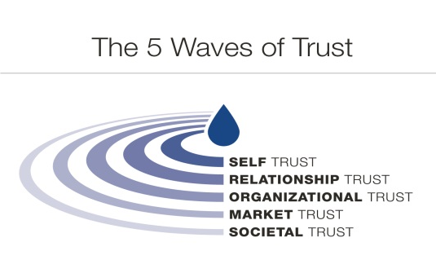
How it works
The course is delivered over 2 days, covering ‘5 Waves of Trust’;

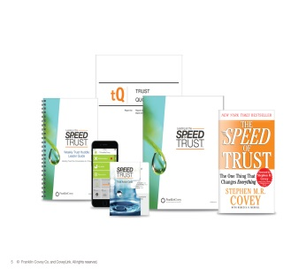
The 2 days are very much structured around the FranklinCovey Speed of Trust materials, with participant packs provided which includes a workbook, set of ‘Trust Action Cards’, a copy of the Stephen Covey book and details of how to access the online App.

During 2016/17 we will be further developing the course to ensure it is more contextualised to the MLAFL programme, enabling participants to discuss exactly how trust and the vision of MLAFL relates to them in their role across the system (either as part of the paid workforce or unpaid (i.e. volunteers)).

Success so far
Over 80% of those who responded to the course evaluation reported that they have put their learning into practice.

One of the participants has reported that they feel the course allows a focus on behaviours and working practice as well as providing a structured way to deal with the day to day running of teams. They have used the trust action cards to prepare for difficult conversations with colleagues within and outside of their own organisation. By ‘stating their intent’ (something covered as part of the
1.“The practice of system leadership: Being comfortable with chaos”, Kings Fund, 2015

course), another participant has reported that they were able to avoid any wasted time with having ineffective conversations.

Attending the course has prompted some participants to actively listen more, for example when conducting personal development reviews with their team. Previously they said they would have been tempted to respond before the individual had finished talking. By using the techniques taught during the course they have improved their communication skills, with a colleague recently feeding back to them that they now appear more confident when they speak.

Many participants have fed back that they have shared their learning with others, sharing their trust action cards for others to use, even helping colleagues to prepare for difficult conversations and structure what they will say.

In addition to the course content, comments below indicate that participants have built networks and met new people who they have subsequently been working with on the MLAFL programme and this has enabled them to quickly build high trust relationships.

“Felt that the opportunity to [attend the course] work with others from across a number of different organisations was hugely valuable, enabling all of us to understand shared drivers and barriers and also to gain insight into factors that are not common.”

“One of the best bits of the course was doing it collaboratively with those from other organisations that we have frequent contact with. Builds trust across organisations. This is especially important on this small Island.”

The course is supporting culture change across the system and developing a ‘common language’. Some participants have embedded the Speed of Trust principles into their own team development programmes and others have now trained to be facilitators for the system wide courses to enable a sustainable provision for the future.

We have received interest from others working in Health and Social Care Systems across the UK who are considering embedding Speed of Trust training into their development plans.

Lessons learnt
The course has proven benefits for those working across the system in enabling people to develop, build and restore trust using the tools and techniques provided. Improved communication and being able to have effective difficult conversations have also been important lessons learnt.

The trust action cards have proven to be invaluable, with many participants reporting that they carry them around to either use themselves or share with others. They have used the cards to prepare for conversations as well as writing emails.

In addition, the strategy to have attendees from across the system learning in mixed groups has proven to enable networks and good working relationships to be developed, as well as for people to be able to find out what it’s like for others who are working in different areas.

Key Contact: Jacqui Skeel, MLAFL Workforce Development Lead - jacqui.skeel@iow.nhs.uk
V1 20.05.2016

