Local Area Coordination (recruitment)
Case study: | Local Area Coordinator Recruitment
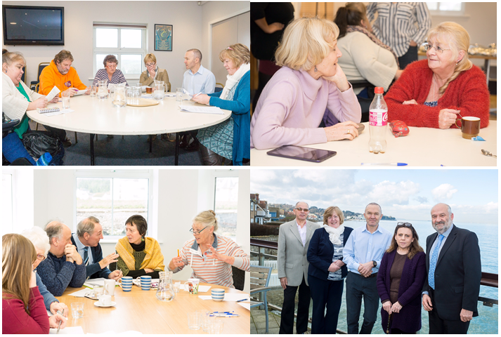
Purpose: | Local Area Coordination is a long term evidence based approach to supporting people with disabilities, mental health needs, older people and their families/carers to:  - build and pursue their vision for a good life  - stay strong, safe and connected as contributing citizens  - find practical, non-service solutions to problems wherever possible  - build more welcoming, inclusive and supportive communities.  The purpose of the interviews is to work with local people to recruit a Local Area Coordinator who will work within a defined Island community.
How to works: | Local people including people with a lived experience of disability, mental health needs, caring and ageing are invited to take part in a day of recruitment activities, following the principles of Local Area Coordination, ensuring inclusion, contribution and citizenship.  The interview days are held in community venues within the recruitment area. 8-25 local people are invited to spend the day with the candidates. The candidates are asked to take part in two timed and scored tasks with community members:  - Using the resources provided, work together to facilitate and map a conversation with community members about existing assets/resources and connections in the local community.  - Building upon the previous activity. Work together to facilitate and record a session with community members where the following questions answered:  - What we love about our community  - What can we do together to make it even better?  - Who do we know that would like to get involved?  After each task the candidates are scored by each member of the community using the following questions:  - Did they introduce everyone and the activity?  - Was the language clear – did they use jargon?  - Did they use eye contact?  - Did they help everyone to contribute/have a voice?  - Did they listen and accurately reflect contributions?  - Do you feel positive, excited by the conversation?  - Are candidates supporting or controlling conversations?  - Do we have something visual that is clear and shows creativity?  - Are they organised?  - Do they sum up at the end?  In the afternoon there is a second part to the interview where each candidate is asked 10 technical questions by a panel of 5 people including the programme manager and the National Network Director the other 3 being drawn from the community members on the day. The responses are scored and added to those from the morning and the person with the highest score is if the panel agree offered the position.  The balance of power lies with the community.
Success so far: | 6 Local Area Coordinators have been appointed by their communities and this has led to the following:  - Introductions from local people to their Local Area Coordinator  - Local understanding of the role  - Local ownership of the Local Area Coordinator and a commitment to support the role.  - Sharing of gifts, assets, skills and opportunities for Local Area Coordinators to use when in post to help build and connect people together, and create more resourceful and inclusive communities  - Community members all felt comfortable in how they could introduce people they know who might benefit from Local Area Coordination and with local organisations that could lead to partnership working for shared outcomes.  - This has mobilised the implementation, integration and embedding of Local Area Coordination within the community.
Lessons learnt: | Need to ensure that a diverse group of community members to ensure there is a more representative cohort of community perspectives within the interview process.  To ensure that the community are able to be fully involved in the development and accountability of the programme going forward.
Key contact: | Heather Rowell – Local Area Coordination Programme Manager – Heather.Rowell@iow.gov.uk

