Telehealth monitoring in Care Homes
Case study: | Telehealth monitoring in Care Homes
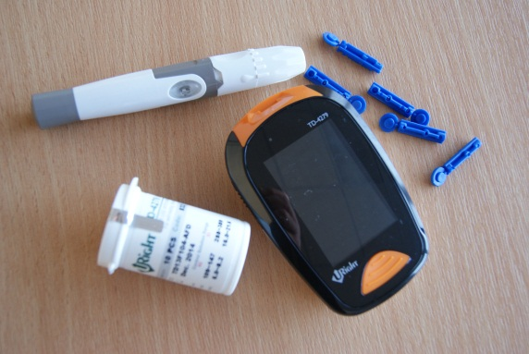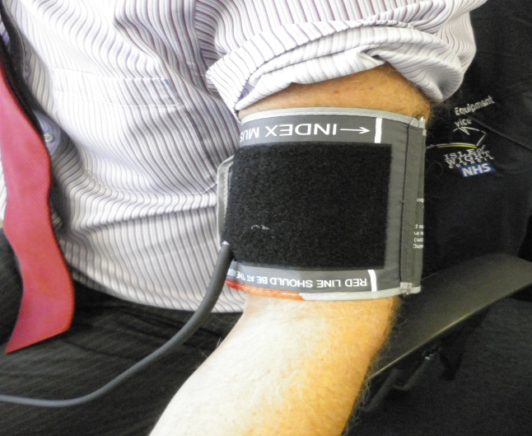
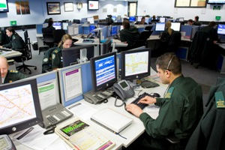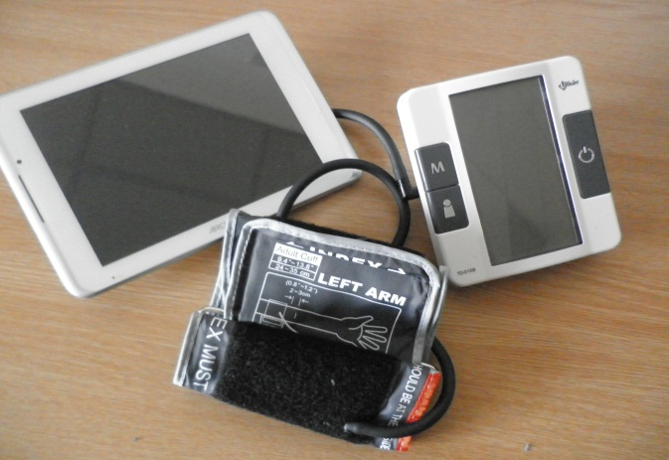
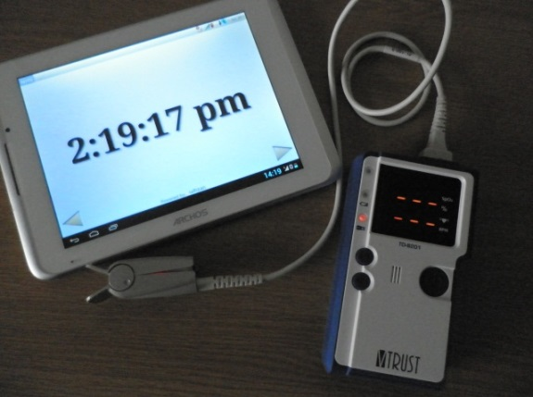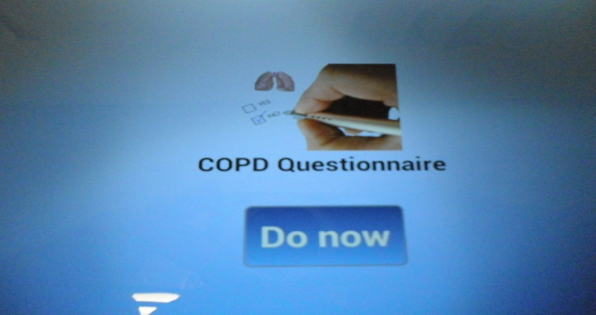

Purpose: | Many areas are embracing technological advances in order to reshape how care is delivered, how information is exchanged and how conditions are monitored. The majority of us use advanced technical devices as part of our daily lives, and there is a need to ensure that these types of digital capability are being used to their full potential to support provision of care outside of hospital.  Supporting My Life a Full Life strategy, Cabrini Salter, has enabled this vision to develop by ensuring resources have been put in place to this project to take place.  The project aims to investigate how Telehealth monitoring can support GP’s to improve their care and support of a patient’s long term conditions. The key driver for this project is to change culture and introduce new models of care to improve patient safety and clinical outcomes.  Working together care home staff and GP’s closely monitor residents on a range of biometric indicators and questionnaires which include the NEWS & MUST scores.  The Telehealth system allows individual parameters to be set for each patient allowing specific monitoring of the patient. The system allows information to be shared with other health professionals to enable a consistent and well informed response.  Aims of the project include:  - Identify a deteriorating trend to enable early intervention  - Prioritising GP home visits  - Reducing hospital admissions  - Improving patient quality, safety and experience  - Improve communication with care home staff and GP’s  - Sharing information with other health care professionals  - Saving time and resources of care homes i.e. staff attending hospital with the client  Dr Cabrini Salter, Lead Locality GP said: “This is about working more closely together, under the principles of My Life a Full Life, to support the dedicated, professional staff working as carers in each of the localities to deliver the best quality care and support to people in the most efficient and effective way. It’s been an extremely positive experience that is bringing different professionals together in a truly integrated way and one that is already making a difference across the Island. We anticipate that the project will go from strength to strength enabling us to support other groups of carers in a similar way!”
How it works: | The following care homes were selected to take part in the project:  - Ward House Nursing Home  - Springfield Nursing Home  - Tile House Residential Home  - Downside House Residential Home  Using the Telehealth system care home staff monitor blood glucose, pulse, weight, temperature, blood pressure, urine analysis and SpO2 on a regular basis. The biometric readings collected allow NEWS and MUST scores to be calculated. Individual parameters can be set for each resident which improves health monitoring and prioritising GP home visits.  Telehealth enables GP’s to remotely monitor their patients within the care homes. Early detection of deteriorating trends allows timely intervention which highlight requirements to change medication or the most appropriate response to a changing situation.  The project consists of three phases:  Phase 1:  Telehealth system implemented in care homes giving GP access to their patient information  Phase 2:  Sharing information to support Out of Hours care including the Integrated Care Hub and Contact Centre  Phase 3:  Increased access to a client’s records by a healthcare professional to support their care
Success so far: | The first stage of the project has been successfully completed. Results show that an early detection and intervention of a deteriorating patient can allow care plans to be modified or a GP response which helps to avert hospital admissions and 999 or 111 calls.  Within the first month of operating two of the care homes have reported saving 4 hospital admissions, 5 calls to the 999 and 111 service and 9 occasions where the monitoring has directly improved patient outcomes. These improvements have included modifying care plans and instigating medication reviews.  The care homes involved are also benefiting from better communication and information sharing with their GP’s saving time for both services.  Feedback received so far:  “Our Team at Tile House feel very passionate about this pilot project, it is empowering the staff and supporting a co-ordinated approach, putting the client at the very heart of their health and welfare”  “Staff like the ease of using”  “Most important we can evidence what we are doing”
Lessons learnt: | - Remote monitoring enables GP’s to identify when medication reviews are required  - Reduction in calls to 999 and 111 service resulting in less hospital admissions.  - Prompting effective communication between GP’s and care home staff.  - Providing easily accessible clinical evidence.
Key contact: | Brian Martin brian.martin@iow.nhs.uk

