CASE STUDY – Integrated care hub
Case study: | Integrated care hub
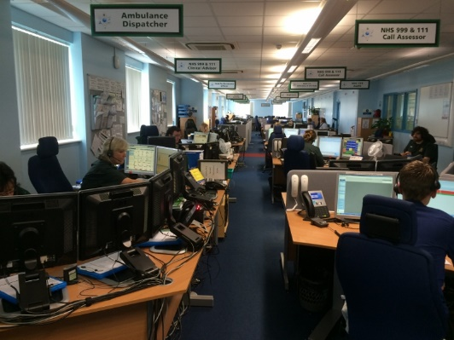
Purpose: | A central part of the My Life a Full Life programme is focused on working better together in a more coordinated and integrated way to provide the best possible care and support in the most seamless, efficient and effective way possible.  One example of this is the innovative integrated care hub based at St Mary’s. It handles ambulance 999, NHS 111, rehabilitation, district nursing, social care and warden assisted housing alarm calls.
How to works: | The team within the hub takes the calls and refers people to the most appropriate service, whether that is delivered by statutory, voluntary or independent services. Staff are co-located and work alongside each other.  In doing so, they are making sure that people’s needs are met in the best possible way but also reducing unnecessary admissions, to hospital, nursing and residential care, or unnecessary utilisation of out of hours care.  We also moved the Wight care system from the Council’s system to the NHS IT network. This enables calls to also be taken by 111 staff so that we can have a consistently applied triage process and 24/7 integrated service provision.
Success so far: | In the initial period (Jan 2014-May 2015), this resulted in 901 interactions and helped avoid 442 admissions to hospital.  We then took that a stage further and ran a pilot with a multi-disciplined crisis response team comprising nursing staff, occupational therapists, social workers and the voluntary sector. They have focused on wrapping 72 hrs of care around elderly and frail patients to enable them to stay within their home environment. This resulted in a reduction in the total cost per referral from £2,106 to £592.90 per person and 726 people avoided unnecessary admissions to hospital.  Since April 2015, the crisis team has seen 922 patients, of which only 87 were admitted in to hospital.  Chris Smith, Clinical Director/Head of the Ambulance Service said: “There are times when people really need to be in hospital to get the care they need but it’s not the right environment for every health or care issue. Often people with less complicated health or care issues are better being treated and cared for in their own home. This is true for people of all ages but particularly the elderly who can sometimes develop increased dependencies from a stay in hospital which can compromise the speed of their recovery.  “The multi-disciplined approach of the integrated hub and crisis response team enables us to take a holistic view of their health and care needs and decide what support is right for that individual and who is best placed to provide it. It’s a system that is already benefiting those who contact us, but which also has the added benefit of saving us valuable resources in the process."
Lessons learnt: | Co-locating our staff and volunteers within the Integrated care hub has been a success. We now need to do more to break down organisational barriers so we can work and operate as one team. Key to this is having a single management structure and moving towards shared technologies and resources so staff across the various disciplines can work jointly together.  This year we will be consulting with GPs and other primary care practitioners to expand the Hub to include primary care, consolidate our resources and train staff across the various different functions. We will also be looking at greater collaborative opportunities in this area with the voluntary and independent sectors.
Key contact: | Chris Smith, Clinical Director, Isle of Wight NHS Trust tel: 01983 822099

