**Care Navigator Team**

**South Locality**  **Central & West Locality North East Locality**

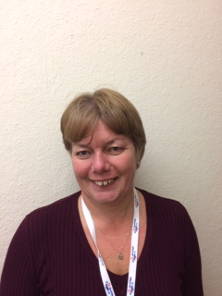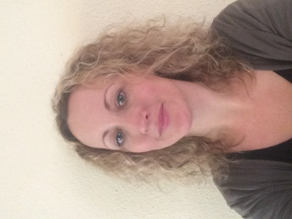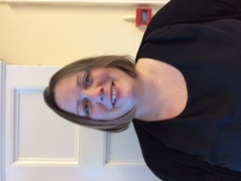 Charlotte Price Kim Williams Rebecca Baker

Care Navigator Team Leader & Care Navigator Central and West Care Navigator North East Locality Lead

South Wight Locality Lead Locality Lead Esplanade Surgery

South Wight Surgery Carisbrooke Health Centre Argyle House Surgery

(Brighstone, Niton & Godshill) East Cowes Medical Centre

Tel: 07496 732 679 Tel: 07496 732 669 Tel: 07496 349 066 [charlotte.price@ageukiw.org.uk](mailto:charlotte.price@ageukiw.org.uk) [kim.williams@ageukiw.org.uk](mailto:kim.williams@ageukiw.org.uk) [rebecca.baker@ageukiw.org.uk](mailto:rebecca.baker@ageukiw.org.uk)

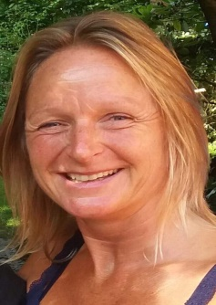

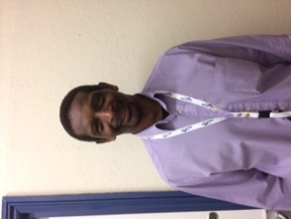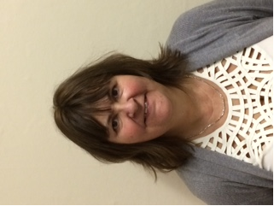 Corinne Moore Rudi Hendon-John Rebecca Cook

Care Navigator Care Navigator Care Navigator

Grove House Surgery Cowes Medical Centre Tower House Surgery

Ventnor Medical Centre Medina Health Care & St Helens Medical Centre

Shanklin Medical Centre Wootton Surgery

Tel: 07947 740 857 Tel: 07947 741 571 Tel: 07496 732 648

[corinne.moore@ageukiw.org.uk](mailto:corinne.moore@ageukiw.org.uk) [rudi.hendon-john@ageukiw.org.uk](mailto:rudi.hendon-john@ageukiw.org.uk) [rebecca.cook@ageukiw.org.uk](mailto:rebecca.cook@ageukiw.org.uk)

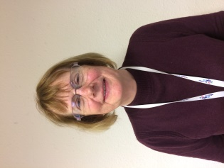

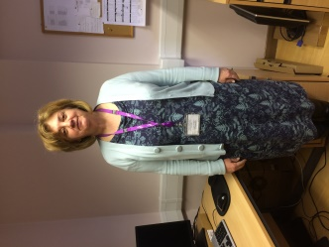 Jenny Trevatt Lesley Oldham

Care Navigator Care Navigator

Beech Grove Surgery West Wight Medical Practice

Sandown Medical Centre (Freshwater & Yarmouth)

Tel: 07971 471 305 Tel: 07496 732 687

[jenny.trevatt@ageukiw.org.uk](mailto:jenny.trevatt@ageukiw.org.uk) [lesley.oldham@ageukiw.org.uk](mailto:lesley.oldham@ageukiw.org.uk)

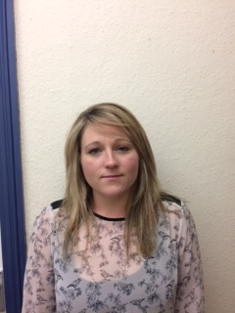

Danielle Filer

Care Navigator

Dower House Surgery

Tel: 07496 349 047

[danielle.filer@ageukiw.org.uk](mailto:danielle.filer@ageukiw.org.uk)