Care Navigator Team
South Locality Central & West Locality North East Locality
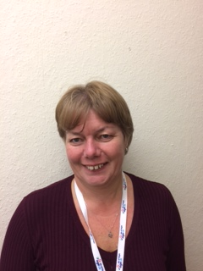
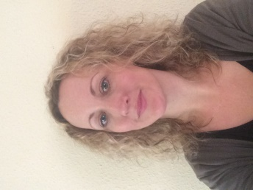
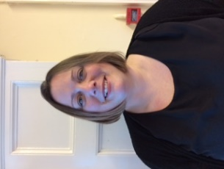
Charlotte Price Kim Williams Rebecca Baker
Care Navigator Team Leader & Care Navigator Central and West Care Navigator North East Locality Lead
South Wight Locality Lead Locality Lead Esplanade Surgery
South Wight Surgery Carisbrooke Health Centre Argyle House Surgery
(Brighstone, Niton & Godshill) East Cowes Medical Centre
Tel: 07496 732 679 Tel: 07496 732 669 Tel: 07496 349 066 charlotte.price@ageukiw.org.uk kim.williams@ageukiw.org.uk rebecca.baker@ageukiw.org.uk

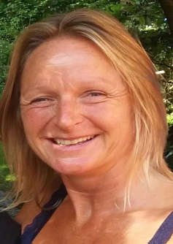
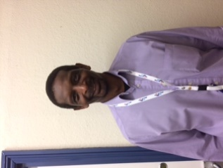
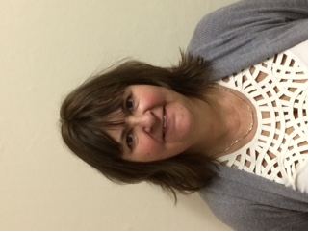
Corinne Moore Rudi Hendon-John Rebecca Cook
Care Navigator Care Navigator Care Navigator
Grove House Surgery Cowes Medical Centre Tower House Surgery
Ventnor Medical Centre Medina Health Care & St Helens Medical Centre
Shanklin Medical Centre Wootton Surgery
Tel: 07947 740 857 Tel: 07947 741 571 Tel: 07496 732 648
corinne.moore@ageukiw.org.uk rudi.hendon-john@ageukiw.org.uk rebecca.cook@ageukiw.org.uk
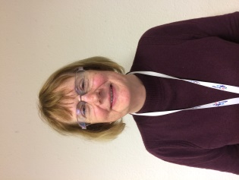
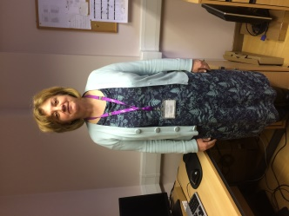
Jenny Trevatt Lesley Oldham
Care Navigator Care Navigator
Beech Grove Surgery West Wight Medical Practice
Sandown Medical Centre (Freshwater & Yarmouth)

Tel: 07971 471 305 Tel: 07496 732 687
jenny.trevatt@ageukiw.org.uk lesley.oldham@ageukiw.org.uk
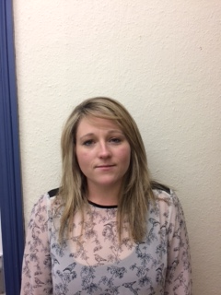
Danielle Filer
Care Navigator
Dower House Surgery
Tel: 07496 349 047
danielle.filer@ageukiw.org.uk

